Exercise-01: DAF Basic Layout Elements

Questions

1. Which of the following layout elements does DAF provide?

|  |  |  |
| --- | --- | --- |
| a | DateElement |  |
| b | FloatElement |  |
| c | IntegerElement |  |
| d | TextElement |  |
| e | Button |  |

2. What is the purpose of the operator nameof?

3. Describe briefly how to create an OptionElement for the Business Data Element weekday in order to display it on the user interface.

Task: EU RENT Basic Layout Elements

Create the following user interface to enter rental information and create a button which will trigger the calculation of the price calculation.

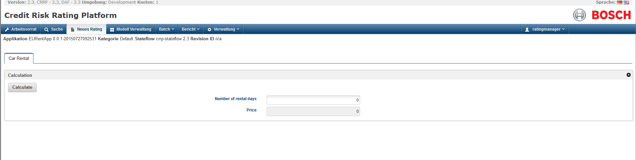

Steps:

1. Create a new DAF Rule Project named EURentApp using the template Application from the Wizard.
2. Create the following input/output parameter for the user interface within the Layout package
   1. TAB_car_rental : type Tab
   2. SEC_calculation : type Section
   3. BUT_calculate : type Button
   4. UI_number_of_rental_days : type IntegerElement
   5. UI_price : type FloatElement
3. Open the rule START_Layout
4. Create an assignment to define the **tab** and set the following attributes:
   1. labelKey : set value “Car Rental”
5. Create an assignment to define the **section** which should be part of the tab and set the following attributes:
   1. labelKey : set value “Calculation”
   2. nameOfReferencedContainer *(Hint: Use NAMEOF operator)*
6. Create a constant data element at the rule model level (*Hint: Create element at the rule model level in order to make it usable in the layout rules and in the business rules*)
   1. EVENT_CALCULATE : type String, Default Value = “event.calculate”
7. Create an assignment to define the **button** which should be part of the section and set the following attributes:
   1. labelKey : set value “Calculate”
   2. nameOfReferencedContainer *(Hint: Use NAMEOF operator)*
   3. eventId(use created constant data element)
8. Create an assignment to define the integer element **number of rental days** which should be part of the section and set the following attributes:
   1. labelKey: set value “Number of rental days”
   2. nameOfReferencedContainer *(Hint: Use NAMEOF operator)*
9. Create an assignment to define the float element **price** which should be part of the section and set the following attributes:
   1. labelKey: set value “Price”
   2. nameOfReferencedContainer *(Hint: Use NAMEOF operator)*
   3. readOnly: set value “TRUE”
10. Build and upload jar file at the platform
    1. click jar button 
    2. select the rule model
    3. if the jar file is build, double click at the file will copy the path to the clipboard
    4. Go to the platform -> Model Administration -> choose file -> activate model and upload
    5. Assign the rule model to your user (Administration -> User Management -> select user and assign the rule mode)
11. Test the uploaded model: Create Rating -> open the model  
    *Note: Warnings will be displayed as there are no referencedDataElements set. Please ignore them you will implement that part in the next steps.*
12. After the layout has been defined the business part needs to be implemented. Create input/outputs at the rule model level in order to store the entered values.
    1. number_of_rental_days : type Integer
    2. calculated_price : type Float
13. Define the attribute nameOfReferenceDataElement in the layout rules at the assignments *(Hint: Use NAMEOF operator)*
    1. UI_number_of_rental_days: set value “number_of_rental_days”
    2. UI_price: set value “calculated_price”
14. To execute a simple calculation, please create a constant data element for the price of a car
    1. PRICE_CAR : type Float, value = 50
15. In order to calculate the price, if the button was clicked, open the rule START_Business
16. Add a decision to this rule and check if the current event (use function getOperationEvent()) equals to the constant data element created in step 6
17. Create a new assignment in case of the calculation event has been triggered
18. Calculate the price in this assignment by multiplying the entered number_of_rental_days with the constant data element created in step 14
19. Build and upload jar file at the platform and test the calculation

Solution: Questions

1. Which of the following layout elements does DAF provide?

|  |  |  |
| --- | --- | --- |
| a | DateElement | x |
| b | FloatElement | x |
| c | IntegerElement | x |
| d | TextElement |  |
| e | Button | x |

2. What is the purpose of the operator nameof?

Returns the name of the referenced data element as a string.

For example: „customer.name“ = nameof customer.name

Excerpt from the Modeling Layout Guide

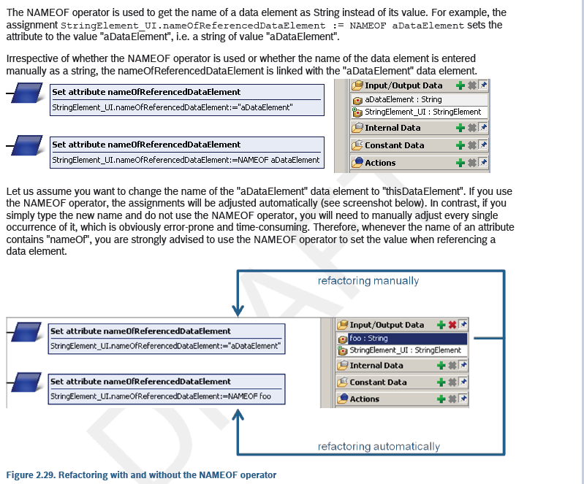

3. Describe briefly how to create an OptionElement for the business data element weekday in order to display it on the user interface.

• Create a data element UI_weekday of type OptionElement in the Layout package

• Set required attributes in the Layout rule (e.g. labelKey, nameOfReferencedContainer)

• Create a data element weekday_options of type Option List defining the possible options (Monday, Tuesday, …) at rule model level

• Reference the Option List weekday_options to the OptionElement UI_weekday (use attribute: nameOfReferencedOptionCollection)

• Bind the chosen option to the business data element weekday using the attribute nameOfReferencedDataElement at the OptionElement UI_weekday

Solution: Modeling EU RENT Basic Layout Elements

Project Explorer

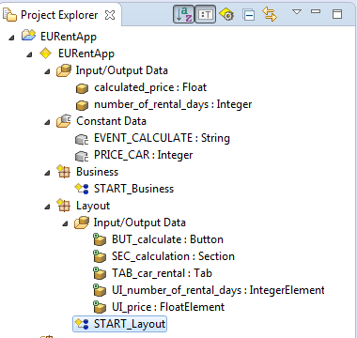

Layout Rules

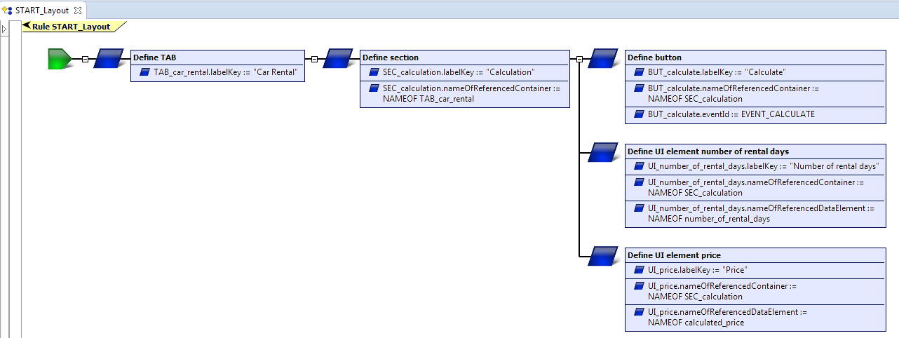

Business Rule to calculate the price

